42.31: 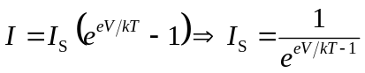
a) 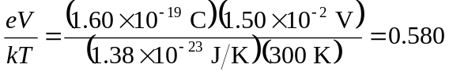
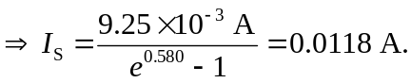
Now for 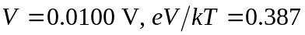
b) Now with 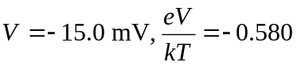
.
If 


